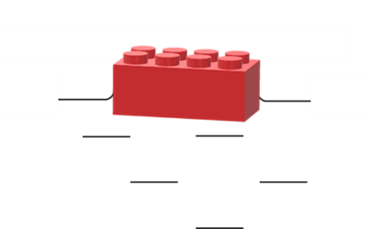
Building bricks

A toy building brick floats on water.

Toy building bricks can be stuck together in a block.
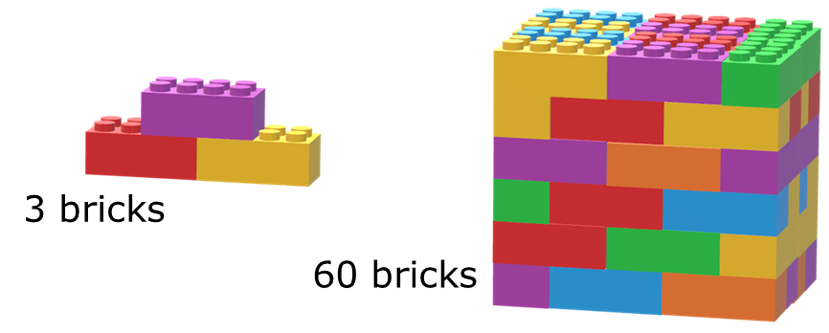
When they are in a block, how many bricks will float?
For each statement, tick (✓) one column to show what you think.
 |  | I am sure this is right | I think this is right | I think this is wrong | I am sure this is wrong
A | A block of three bricks will float.
B | A block of sixty bricks will float.
C | A block of a thousand bricks will float.

Physics > Big idea: PMA Matter > Topic PMA2: Floating and sinking > Key concept PMA2.1: Floating, sinking and density
Diagnostic question
Building bricks

Overview
Learning focus: | An object that is surrounded by a fluid (liquid and/or gas) floats if its overall density is less than the density of the fluid.
Observable learning outcome: | Describe how the mass and volume of an object affect how well it floats.
Question type: | Confidence grid
Key words: | Floating, sinking, weight, volume, density

What does the research say?
In a study of 13-14 year olds (n=120), Ȕnal and Coştu (2005) found that about half of students thought that the main factor influencing whether an object floated or not was its weight or mass. It is quite common for young children to think all light objects float, and all heavy objects sink (Allen, 2014). In Ȕnal and Coştu’s study many students identified the volume of an object as also playing a part in whether or not an object floated, but approximately 40% had difficulties in describing density and in comparing the densities of different objects. A surprising finding was that over half of students thought that increasing the volume of liquid in a container would make objects float more easily. Biddulph and Osborne (1984) found that up to 35% of 11- to 12-year-olds held this view.
Paik et al. (2017) describe a learning progression for buoyancy that begins with the basic concepts of weight and volume, before starting to develop the scientific concepts of density and buoyancy. In their progression, the density of an object is introduced as the object being heavy (or light) for its size. This working definition of density allows students to develop understanding of how volume and weight combine to give an object its buoyancy, and provides descriptive tools that help explain why boat-shaped objects (that are filled with air) are more buoyant than other more compact shapes. This idea is also linked to the understanding that buoyancy increases as the volume of liquid (or gas) displaced increases. Buoyancy is defined as the resultant upward force of the liquid (or gas) around an object, on the object.
Ways to use this question
Students should complete the confidence grid individually. This could be a pencil and paper exercise, or you could use an electronic ‘voting system’ or mini white boards and the PowerPoint presentation.
If there is a range of answers, you may choose to respond through structured class discussion. Ask one student to explain why they gave the answer they did; ask another student to explain why they agree with them; ask another to explain why they disagree, and so on. This sort of discussion gives students the opportunity to explore their thinking and for you to really understand their learning needs.

Differentiation
You may choose to read the questions to the class, so that everyone can focus on the science. In some situations it may be more appropriate for a teaching assistant to read for one or two students.
Equipment
For the class (optional demonstration):
- Lego bricks (or similar)
- Glass trough of water
Expected answers
All three statements are correct.
How to respond - what next?
As more toy bricks are added, the block gets heavier and heavier. It is common for students to think that when it becomes ‘heavy enough’ it will sink. This does not happen because as more toy bricks are added, the volume of the block also increases.
One toy brick floats not necessarily because it is light, but because it is ‘light for its size’. A large block of toy building blocks can be heavy, but it is not ‘heavy for its size’. With ten times more toy bricks a block weighs ten times as much, but it also has ten times the volume. This means that ‘for its size’ it is not any heavier - it has the same density. The density of the block determines whether or not it floats, rather than weight (or mass) or volume alone.
It is helpful for students to develop understanding that density is how heavy something is for its size, and of how it determines whether something floats or sinks, before measuring or calculating density. Calculating density is not necessary for understanding floating and sinking, and adds to the cognitive load.
If students have misunderstandings about how mass (or weight) and volume affect how well an object floats, it can help to challenge them with practical examples that show mass or volume alone do not determine whether an object floats or sinks. This can be done by comparing ‘density blocks’ of different sizes and masses, and challenging students to predict and explain what they think will happen. This is described in more detail in the following BEST ‘response activity’, which could be used in follow-up to this diagnostic question:
- Response activity: Block work
Acknowledgments
Developed by Peter Fairhurst (UYSEG).
Images: Peter Fairhurst (UYSEG).
References
Allen, M. (2014). Misconceptions in Primary Science, 2nd edn Berkshire, UK: Open University Press.
Biddulph, F. and Osborne, R. (1984). Pupils' ideas about floating and sinking. Australian Science Education Research Association Conference. Melbourne.
Paik, S.-H., et al. (2017). Developing a Four-level Learning Progression and Assessment for the Concept of Buoyancy. Eurasia journal of mathematics, science and technology education, 13(8), 4965-4986.
Unal, S. and Costu, B. (2005). Problematic issue for students: Does it sink or float? Asia-Pacific Forum on Science Learning and Teaching, 6(1), Article 3.

